

|  |  |
| --- | --- |
| **Monday Activity Schedule** | |
| * **Check It Off When Completed** | **Activity** |
|  | Morning Work |
|  | Writing Journal page |
|  | Reading Comprehension Worksheet |
|  | Read a book and Story Map |
|  | 25 minutes of Lexia or RazKids |
|  | Math Worksheet |
|  | 30 minutes of SplashMath or Zearn |
|  | Skills Worksheet |
|  | *Choice activity time: pick an activity from the ClassDojo class story (watch a read aloud, try a learning website, or reading journal entry) or independent read for 20 minutes |

Morning Work- **Monday**

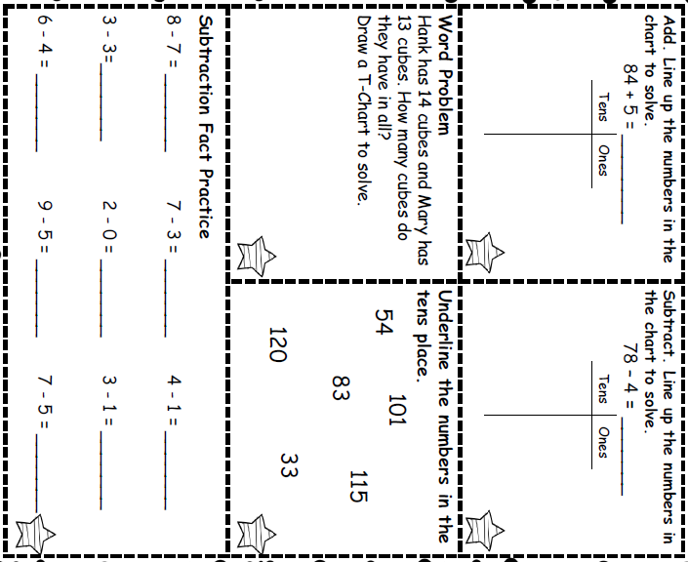

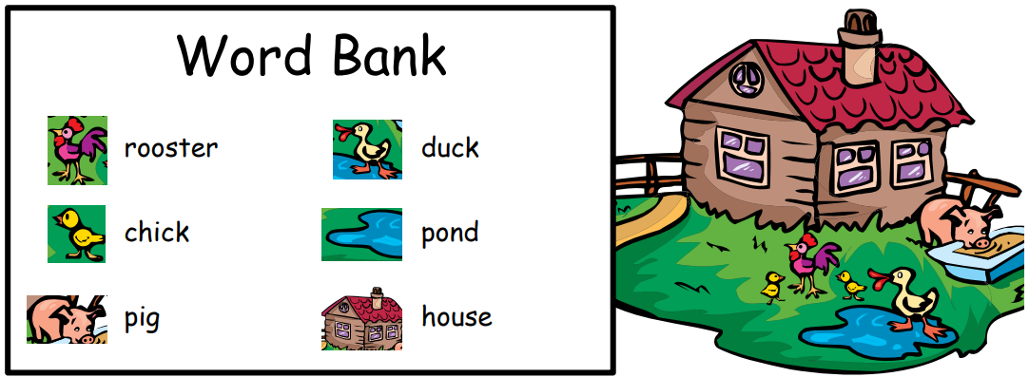

_______________________________________________________________________________________________________________________________________________________________________________________________________________________________________________________________________________________________________________________________________________________________________________________________________________________________________________________________________________________________________________________________________________________________________________________________________________

Monday- Writing

Write a story about a farm.

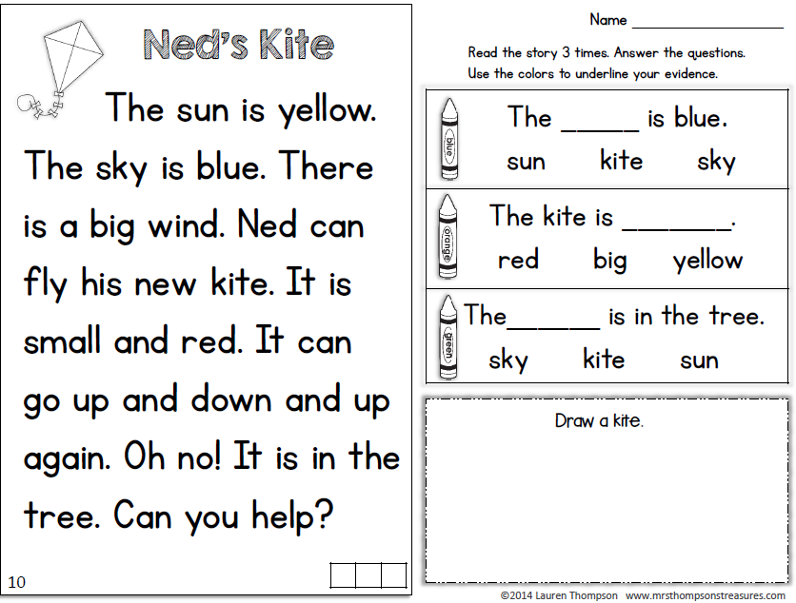

Monday- Reading

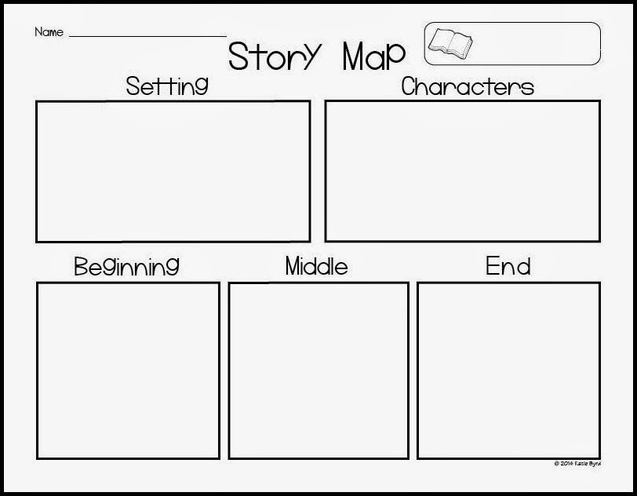

* Read a book and complete this story map.****

Monday- Reading

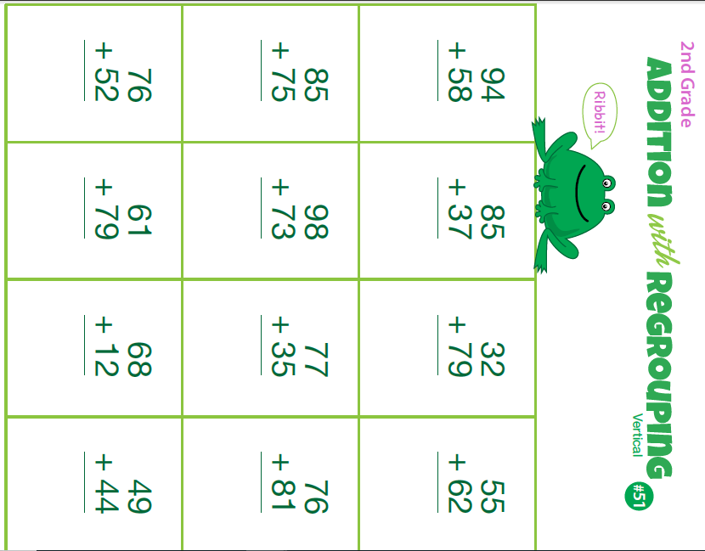

Monday- Math

Pat made 10 red cupcakes and 4 green cupcakes. His friend Beth made 5 yellow cupcakes. How many cupcakes do they have altogether?

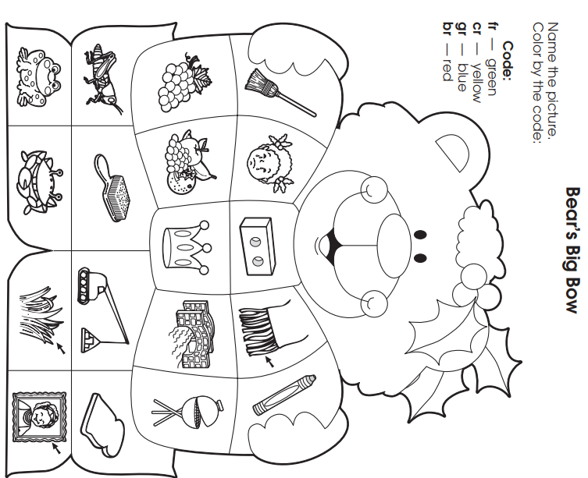

Monday- Skills

|  |  |
| --- | --- |
| **Tuesday Activity Schedule** | |
| * **Check It Off When Completed** | **Activity** |
|  | Morning Work |
|  | Writing Journal page |
|  | Reading Comprehension Worksheet |
|  | Read a book and Story Map |
|  | 25 minutes of Lexia or RazKids |
|  | Math Worksheet |
|  | 30 minutes of SplashMath or Zearn |
|  | Skills Worksheet |
|  | *Choice activity time: pick an activity from the ClassDojo class story (watch a read aloud, try a learning website, or reading journal entry) or independent read for 20 minutes |



Morning Work- **Tuesday**

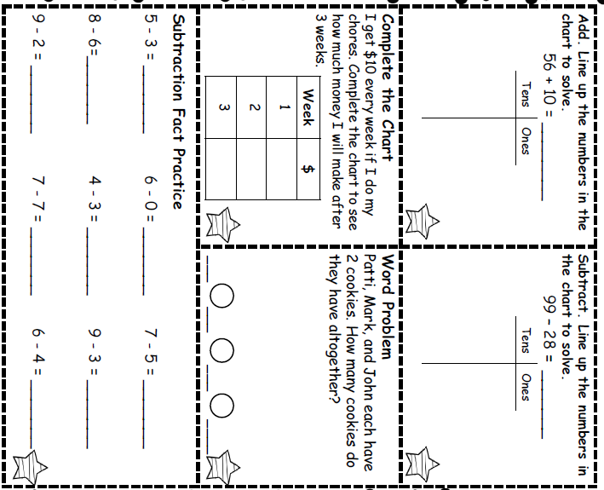

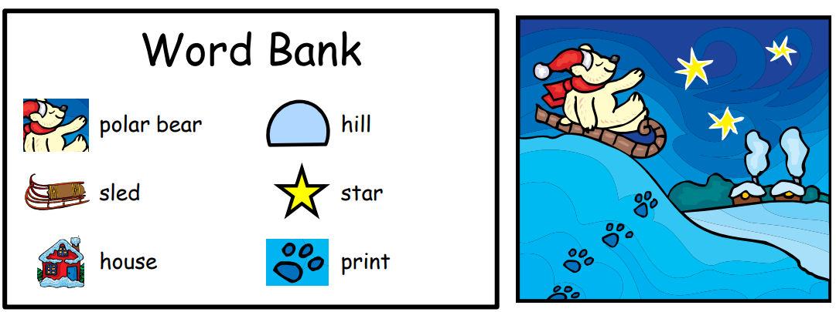

_______________________________________________________________________________________________________________________________________________________________________________________________________________________________________________________________________________________________________________________________________________________________________________________________________________________________________________________________________________________________________________________________________________________________________________________________________________

Tuesday- Writing

Write a story about a polar bear.

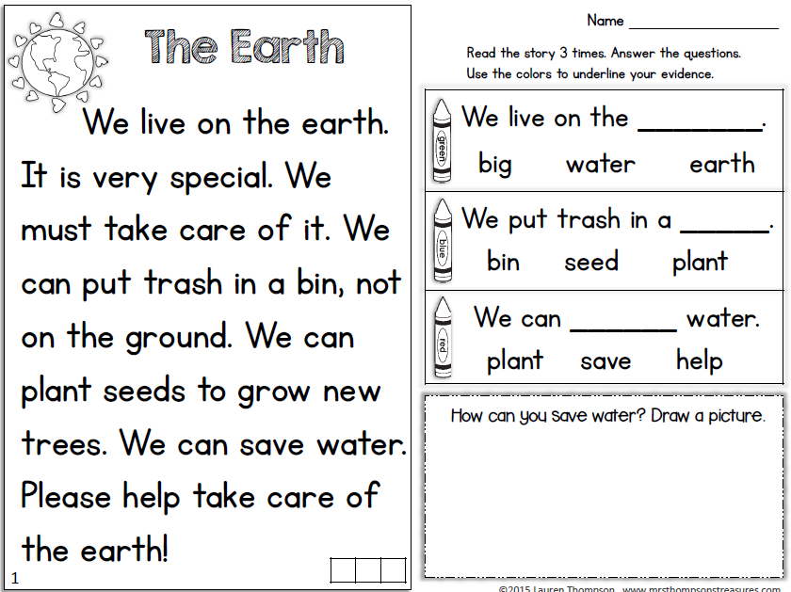

Tuesday- Reading

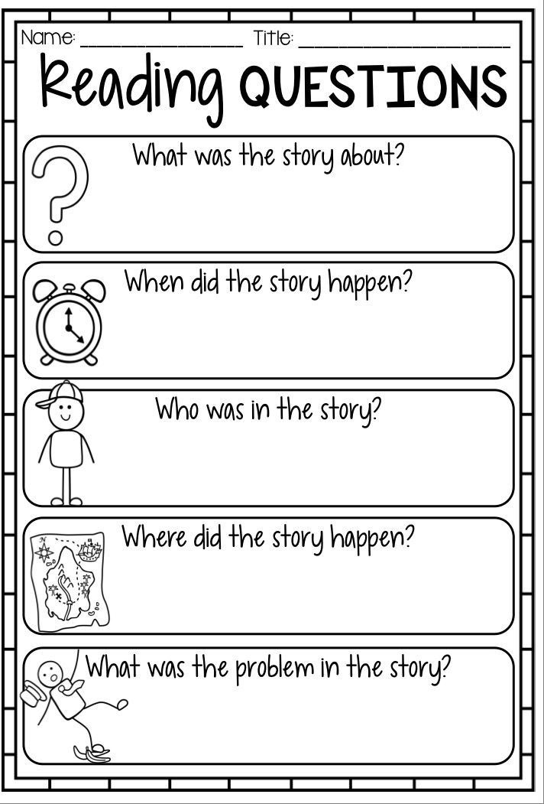

Read a book and complete this story map

Tuesday- Reading

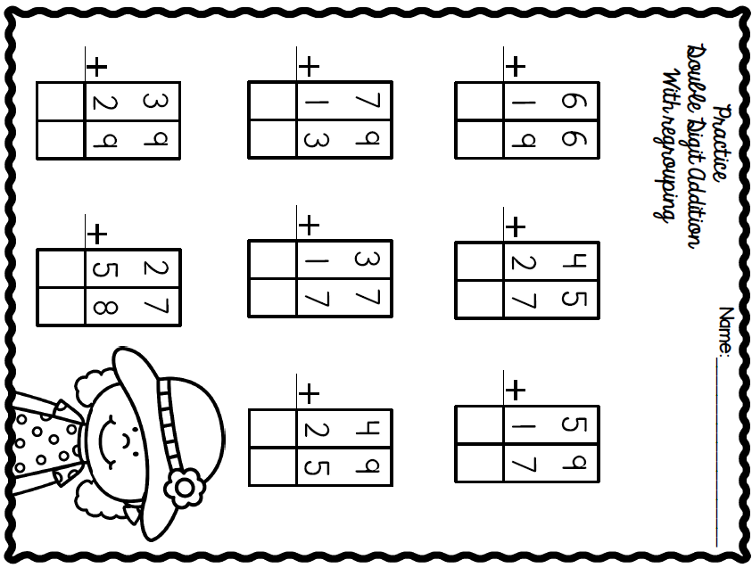

Tuesday- Math

Tuesday- Skills

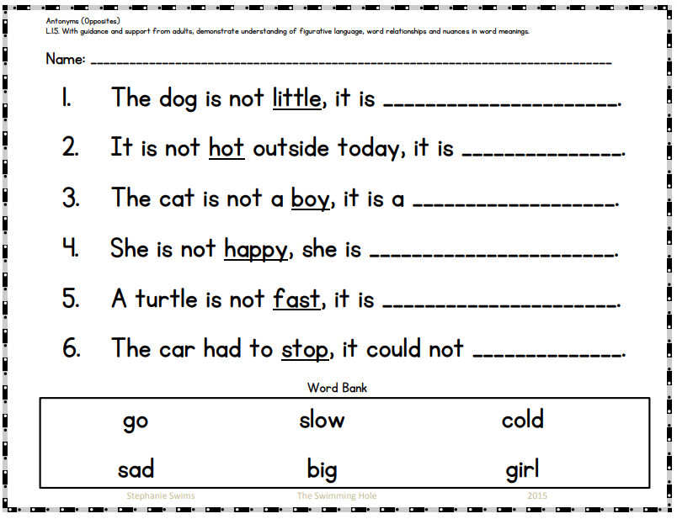



|  |  |
| --- | --- |
| **Wednesday Activity Schedule** | |
| * **Check It Off When Completed** | **Activity** |
|  | Morning Work |
|  | Writing Journal page |
|  | Reading Comprehension Worksheet |
|  | 40 minutes of Lexia or RazKids |
|  | Math Worksheet |
|  | 40 minutes of SplashMath or Zearn |
|  | Skills Worksheet |
|  | *Choice activity time: pick an activity from the ClassDojo class story (watch a read aloud, try a learning website, or reading journal entry) or independent read for 20 minutes |

|  |  |
| --- | --- |
| **Tuesday Activity Schedule** | |
| * **Check It Off When Completed** | **Activity** |
|  | Morning Work |
|  | Writing Journal page |
|  | Reading Comprehension Worksheet |
|  | Read a book and Story Map |
|  | 25 minutes of Lexia or RazKids |
|  | Math Worksheet |
|  | 30 minutes of SplashMath or Zearn |
|  | Skills Worksheet |
|  | *Choice activity time: pick an activity from the ClassDojo class story (watch a read aloud, try a learning website, or reading journal entry) |

Morning Work- **Wednesday**

|  |  |
| --- | --- |
| **Tuesday Activity Schedule** | |
| * **Check It Off When Completed** | **Activity** |
|  | Morning Work |
|  | Writing Journal page |
|  | Reading Comprehension Worksheet |
|  | Read a book and Story Map |
|  | 25 minutes of Lexia or RazKids |
|  | Math Worksheet |
|  | 30 minutes of SplashMath or Zearn |
|  | Skills Worksheet |
|  | *Choice activity time: pick an activity from the ClassDojo class story (watch a read aloud, try a learning website, or reading journal entry) |

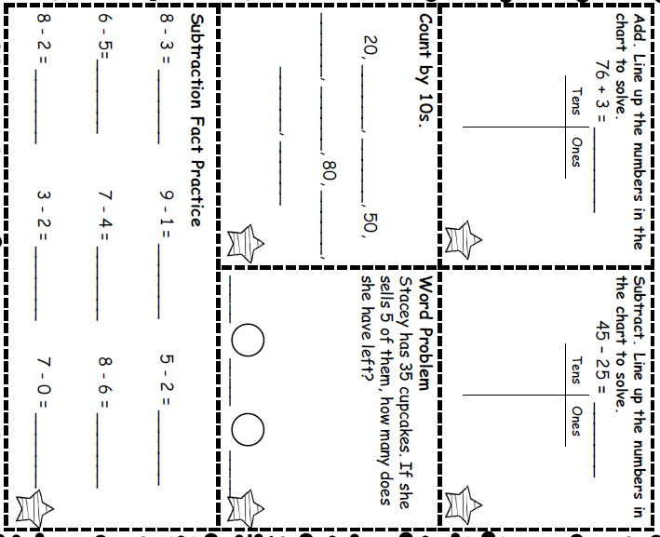

Wednesday - Reading

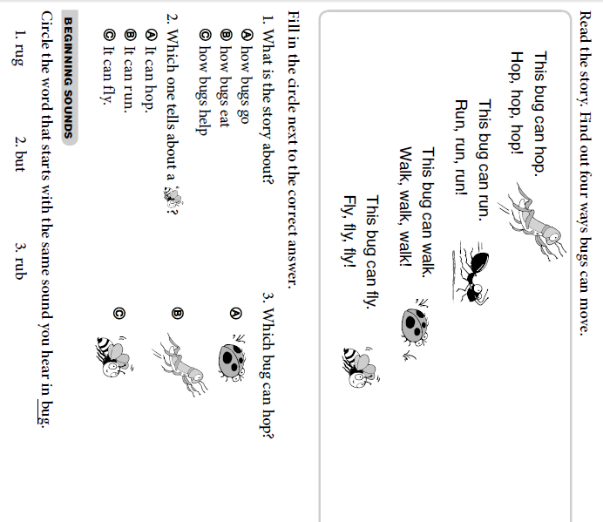

Wednesday- Writing

Write a story about a castle.

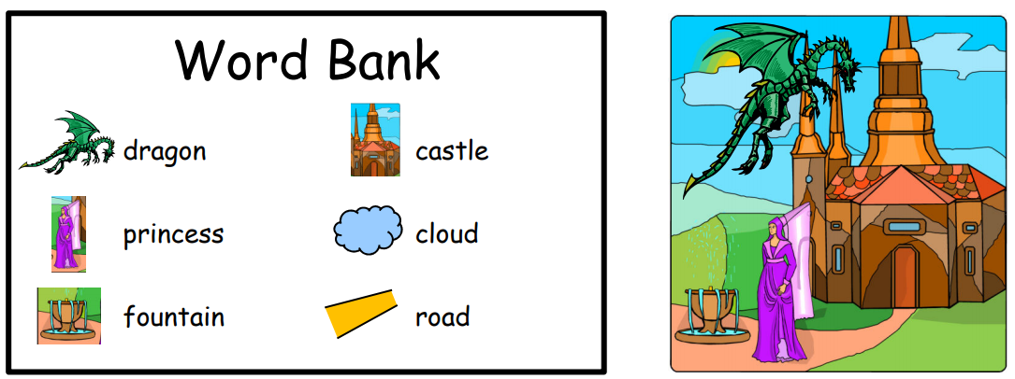

_______________________________________________________________________________________________________________________________________________________________________________________________________________________________________________________________________________________________________________________________________________________________________________________________________________________________________________________________________________________________________________________________________________________________________________________________________________

Wednesday- Math

Seth collected 24 toy cars. His sister collected 17 toy cars. How many toy cars do they have in all?

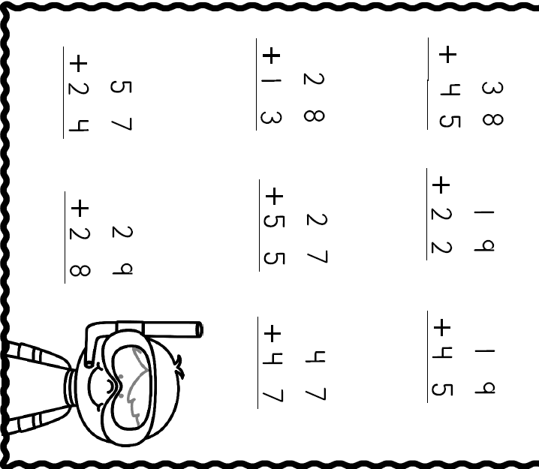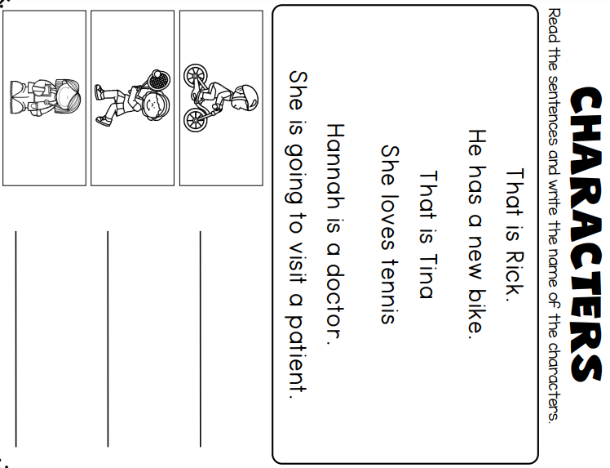

Wednesday- Skills



|  |  |
| --- | --- |
| **Thursday Activity Schedule** | |
| * **Check It Off When Completed** | **Activity** |
|  | Morning Work |
|  | Writing Journal page |
|  | Reading Comprehension Worksheet |
|  | Read a book and story map |
|  | 30 minutes of Lexia or RazKids |
|  | Math Worksheet |
|  | 30 minutes of SplashMath or Zearn |
|  | Skills Worksheet |
|  | *Choice activity time: pick an activity from the ClassDojo class story (watch a read aloud, try a learning website, or reading journal entry) or independent read for 20 minutes |

Morning Work- **Thursday**

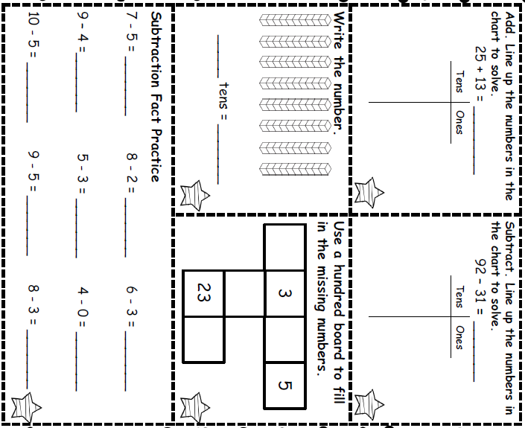

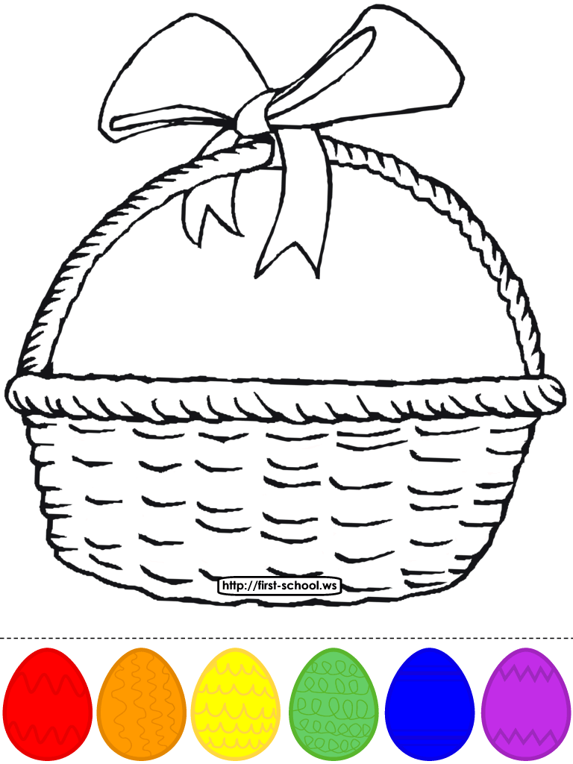

Thursday- Writing

**Words to use**:

* egg
* eyes
* basket
* look

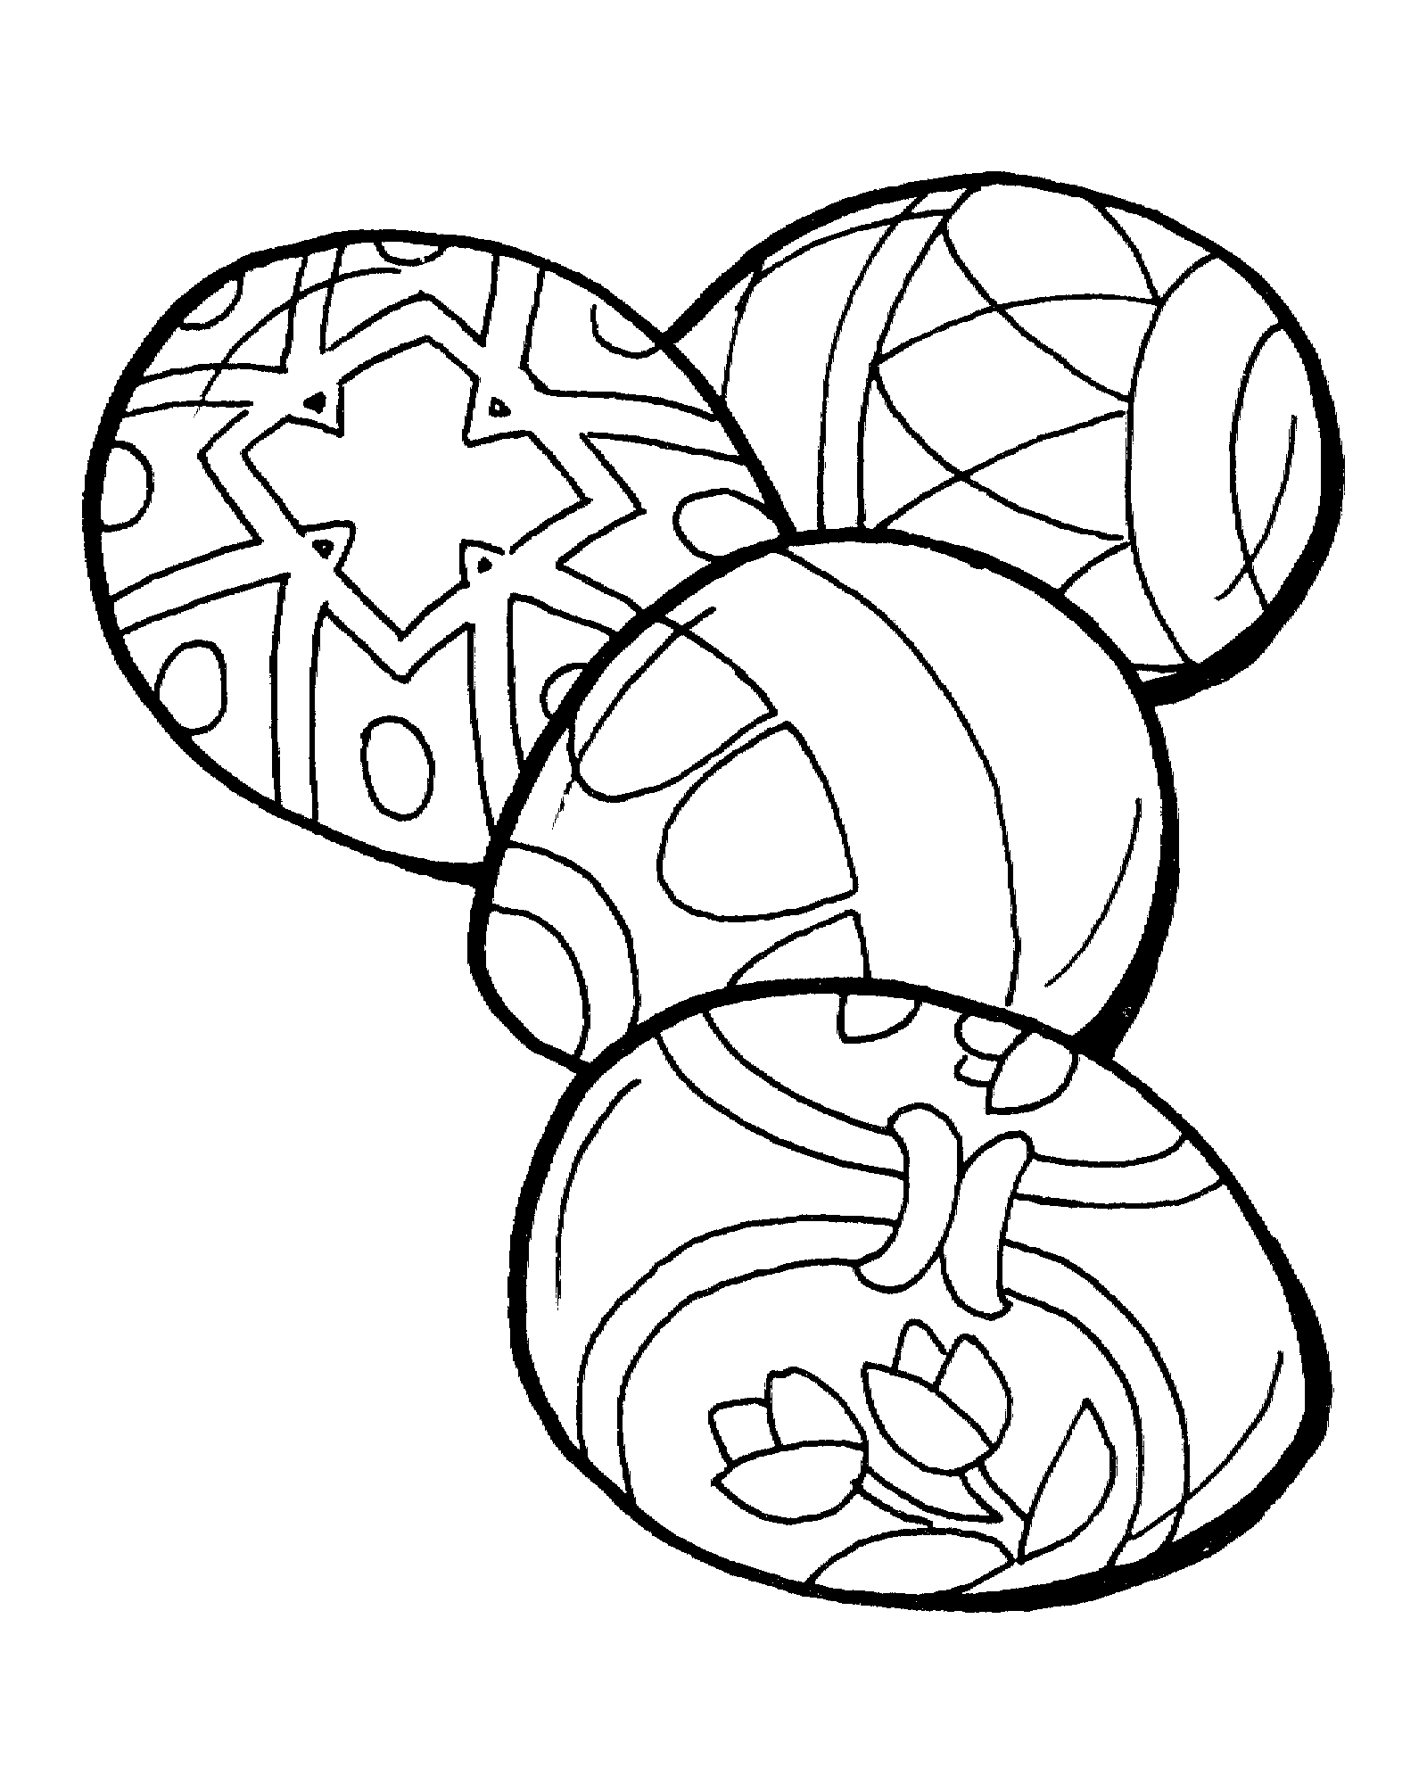

_________________________________________________________________________________________________________________________________________________________________________________________________________________________________________________________________________________________________________________________________________________________________________________________________________________________________________________________________________________________

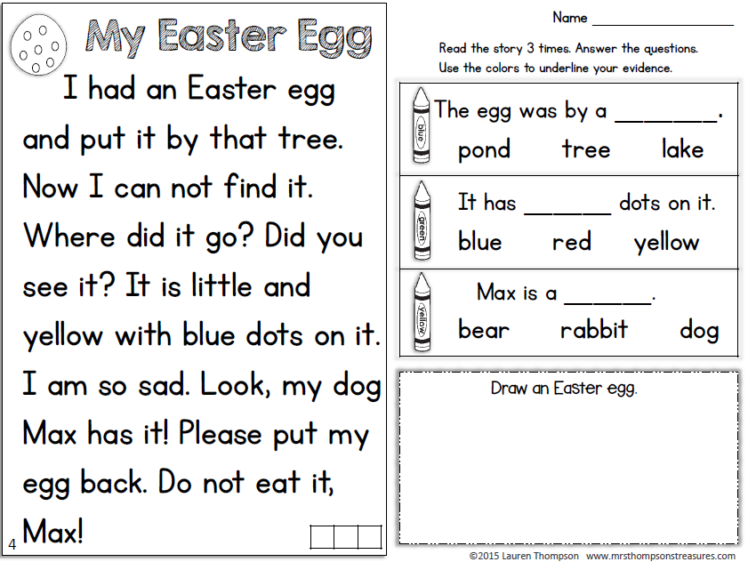

Thursday- Reading

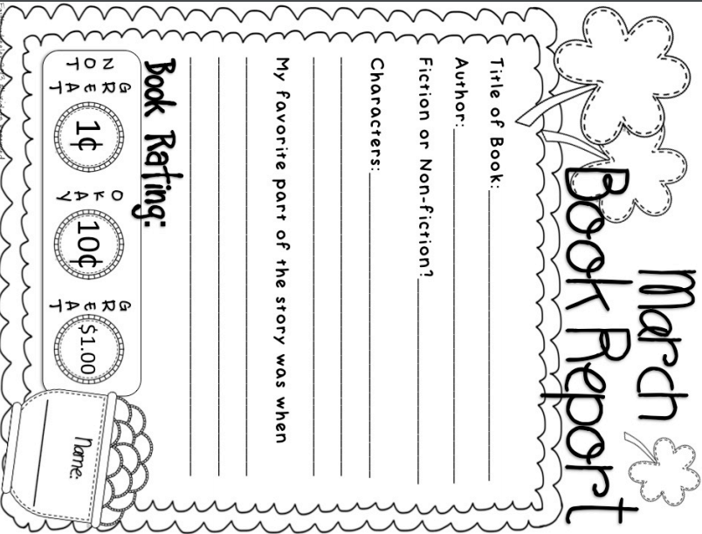

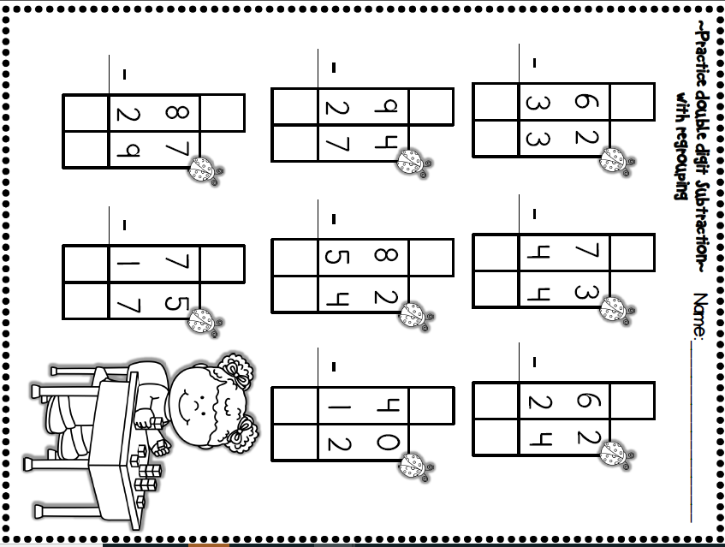

Thursday- Math

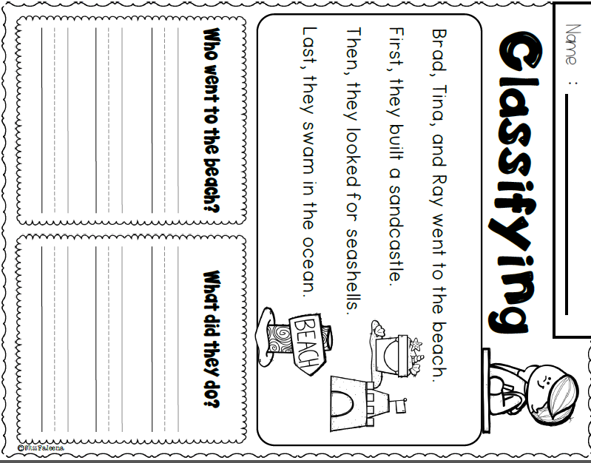

Thursday Skills



|  |  |
| --- | --- |
| **Friday Activity Schedule** | |
| * **Check It Off When Completed** | **Activity** |
|  | Morning Work |
|  | Writing Journal page |
|  | Reading Comprehension Worksheet |
|  | 40 minutes of Lexia or RazKids |
|  | Math Worksheet |
|  | 40 minutes of SplashMath or Zearn |
|  | Skills Worksheet |
|  | *Choice activity time: pick an activity from the ClassDojo class story (watch a read aloud, try a learning website, or reading journal entry) or independent read for 20 minutes |

Morning Work- **Friday**

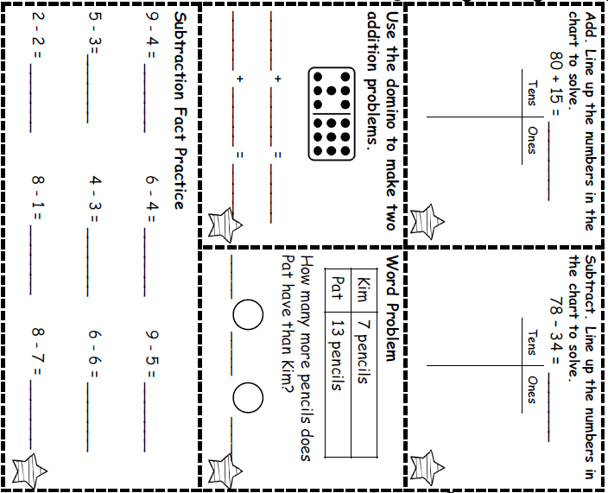



Friday Writing

**Words to use**:

* egg
* stuck
* rabbit
* bumping

___________________________________________________________________________________________________________________________________________________________________________________________________________________________________________________________________________________________________________________________________________________________________________________________________________________________________________________________________________________________________________________________________

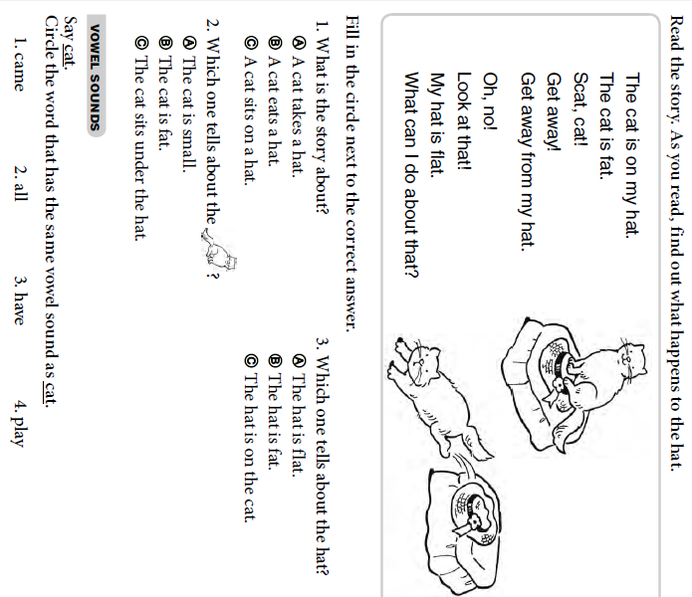

Friday Reading

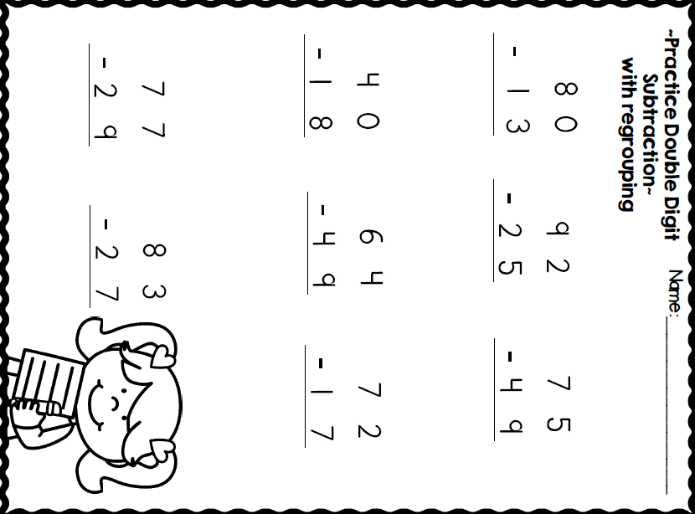

Friday Math

Friday Skills

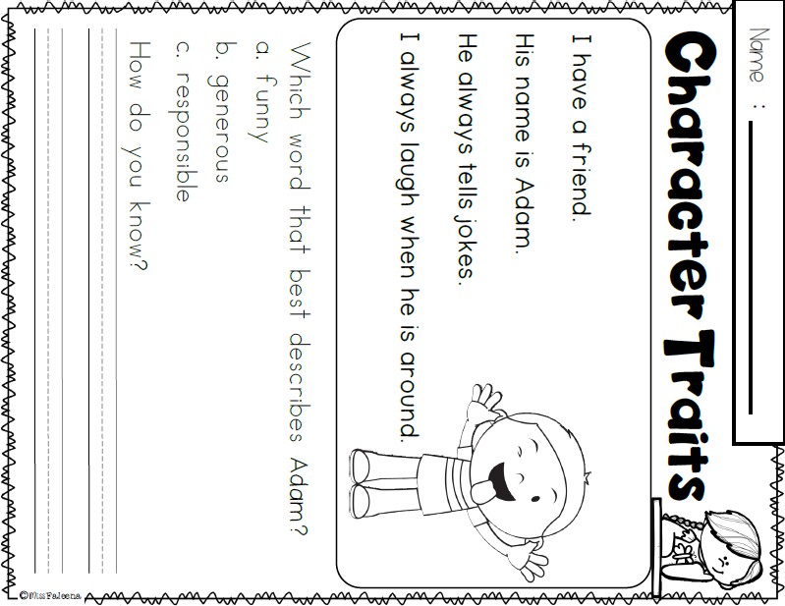



|  |  |
| --- | --- |
| **Monday Activity Schedule** | |
| * **Check It Off When Completed** | **Activity** |
|  | Morning Work |
|  | Writing Journal page |
|  | Reading Comprehension Worksheet |
|  | Read a book and Story Map |
|  | 25 minutes of Lexia or RazKids |
|  | Math Worksheet |
|  | 30 minutes of SplashMath or Zearn |
|  | Skills Worksheet |
|  | *Choice activity time: pick an activity from the ClassDojo class story (watch a read aloud, try a learning website, or reading journal entry) or independent read for 20 minutes |



Morning Work- **Monday**

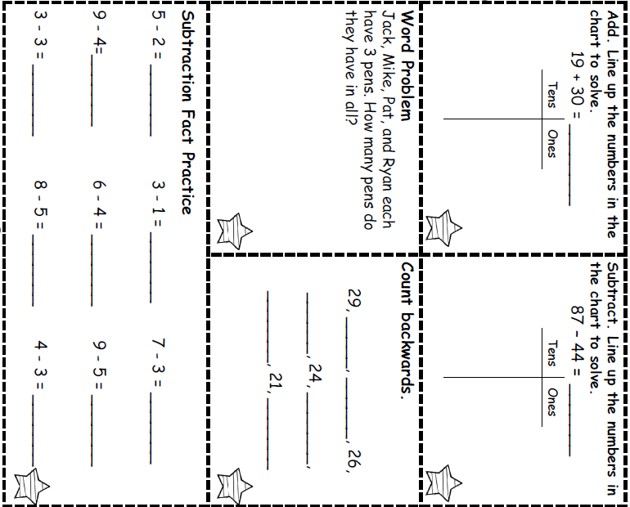

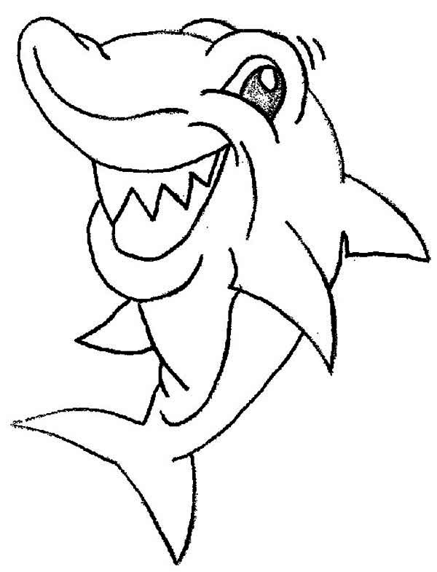

**Words to use**:

* shark
* fish
* camera
* shades

Monday- Writing

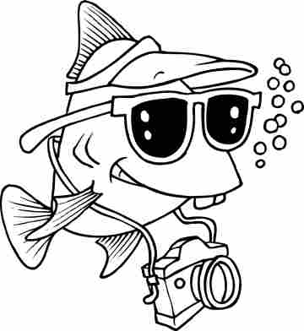

________________________________________________________________________________________________________________________________________________________________________________________________________________________________________________________________________________________________________________________________________________________________________

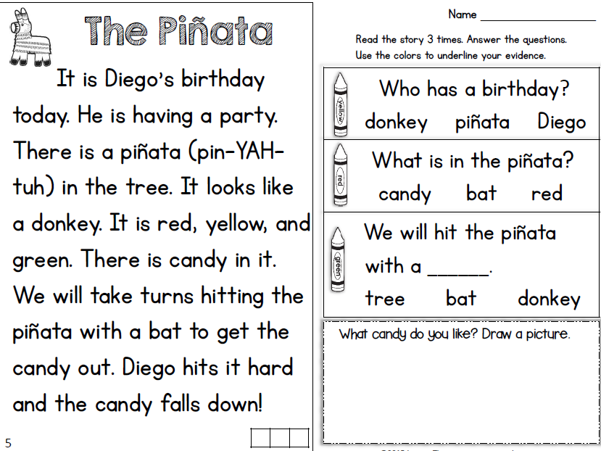

Monday- Reading



* Read a book and complete this story map.****

Monday- Reading

Monday- Math

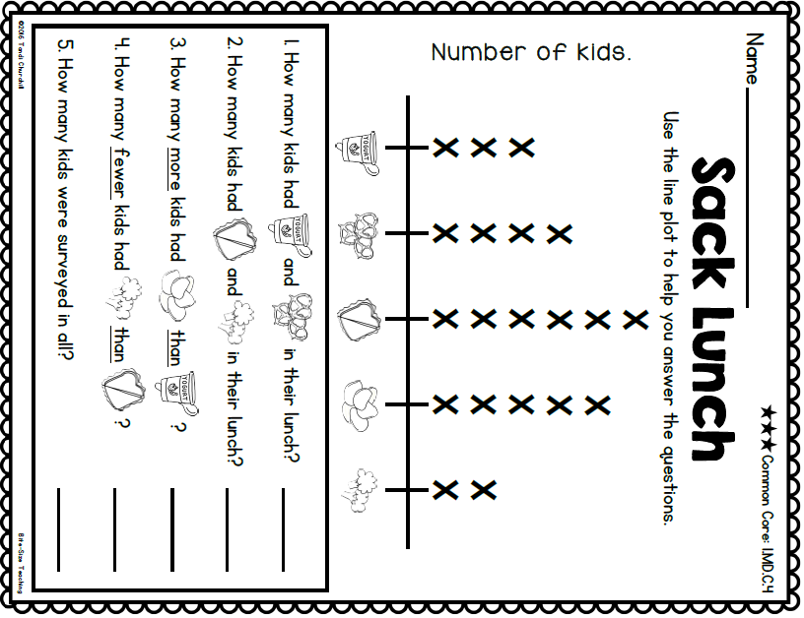

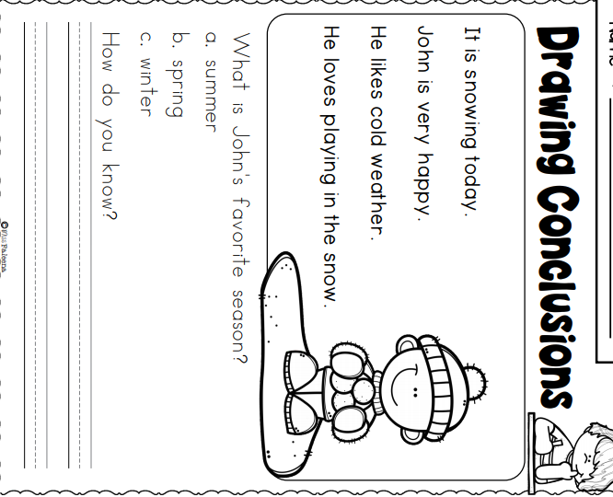

Monday- Skills

|  |  |
| --- | --- |
| **Tuesday Activity Schedule** | |
| * **Check It Off When Completed** | **Activity** |
|  | Morning Work |
|  | Writing Journal page |
|  | Reading Comprehension Worksheet |
|  | Read a book and Story Map |
|  | 25 minutes of Lexia or RazKids |
|  | Math Worksheet |
|  | 30 minutes of SplashMath or Zearn |
|  | Skills Worksheet |
|  | *Choice activity time: pick an activity from the ClassDojo class story (watch a read aloud, try a learning website, or reading journal entry) or independent read for 20 minutes |



Morning Work- **Tuesday**

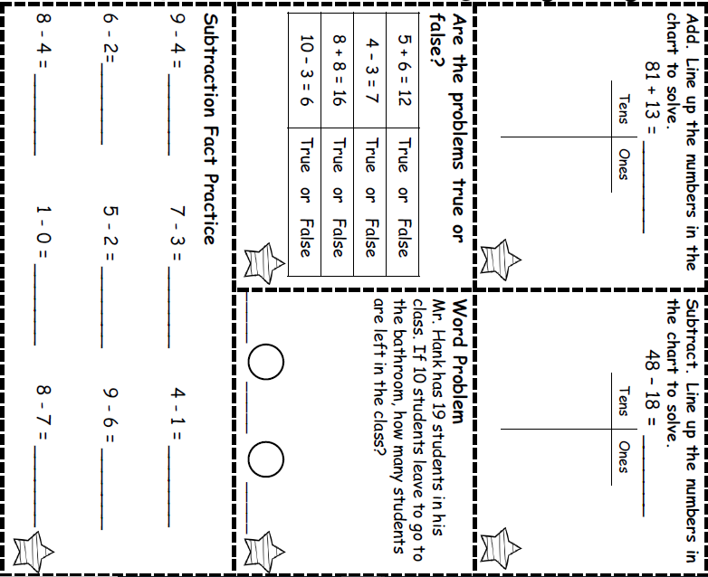

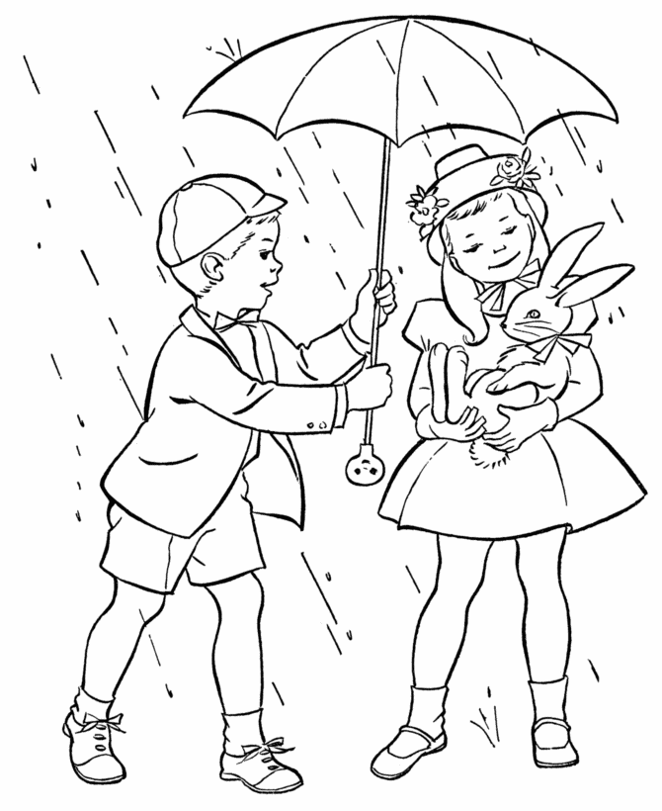_________________________

**Words to use**:

* rain
* rabbit
* umbrella
* holding

Tuesday- Writing

________________________________________________________________________________________________________________________________________________________________________________________________________________________________________________________________________________________________________________________________________________________________________

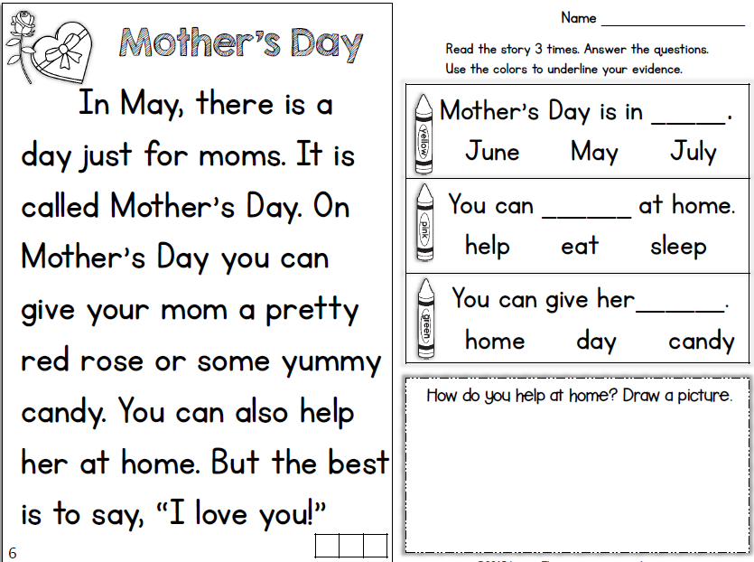

Tuesday- Reading



Read a book and complete this story map

Tuesday- Reading

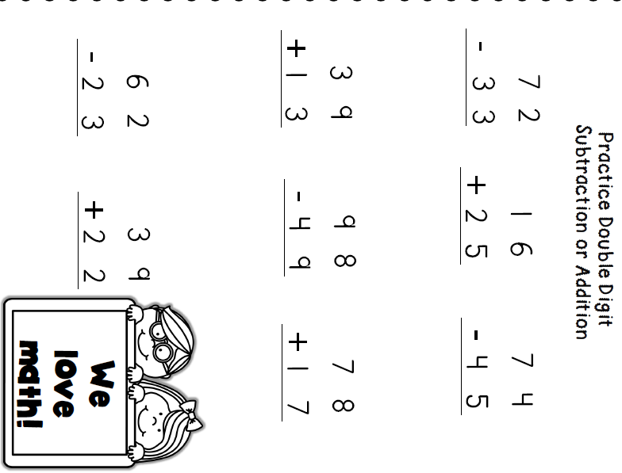

Tuesday- Math

Tuesday- Skills

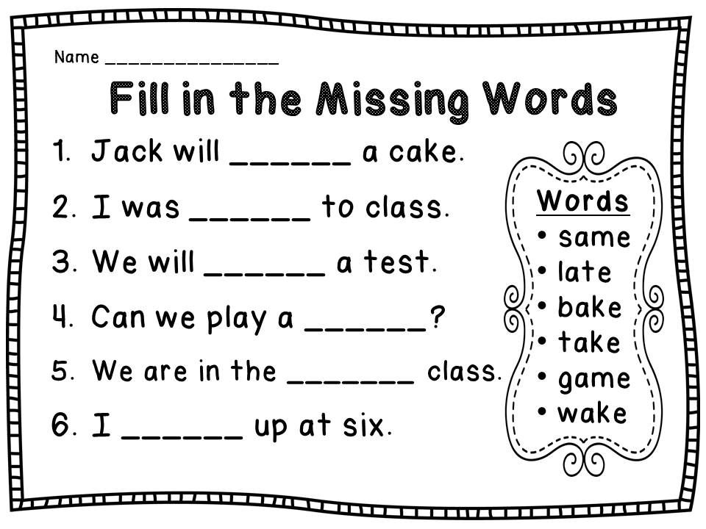



|  |  |
| --- | --- |
| **Wednesday Activity Schedule** | |
| * **Check It Off When Completed** | **Activity** |
|  | Morning Work |
|  | Writing Journal page |
|  | Reading Comprehension Worksheet |
|  | 40 minutes of Lexia or RazKids |
|  | Math Worksheet |
|  | 40 minutes of SplashMath or Zearn |
|  | Skills Worksheet |
|  | *Choice activity time: pick an activity from the ClassDojo class story (watch a read aloud, try a learning website, or reading journal entry) or independent read for 20 minutes |



Morning Work- **Wednesday**

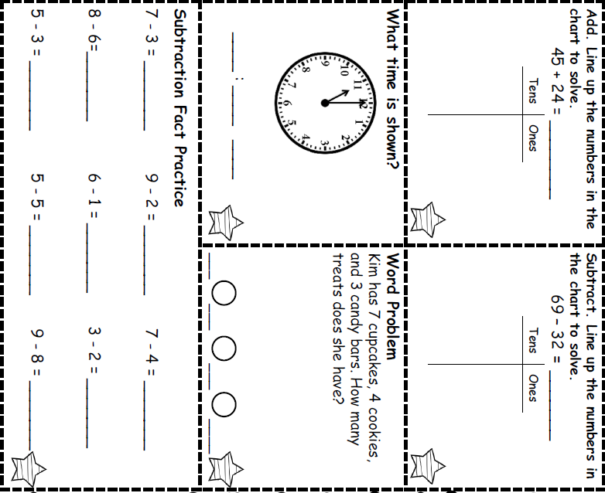

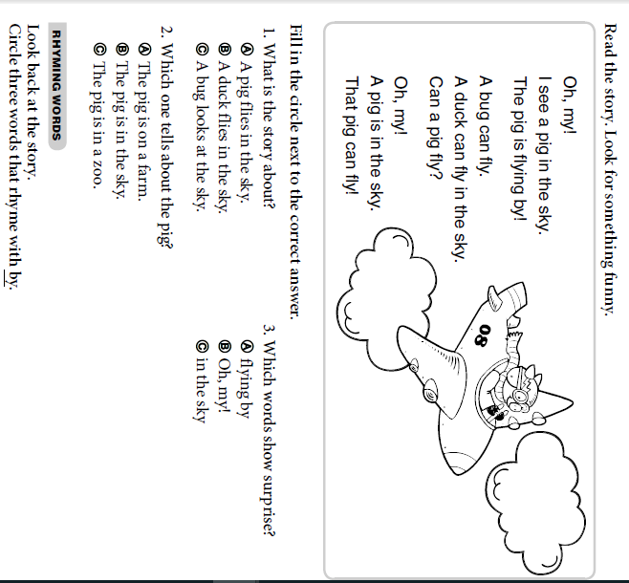

Wednesday - Reading

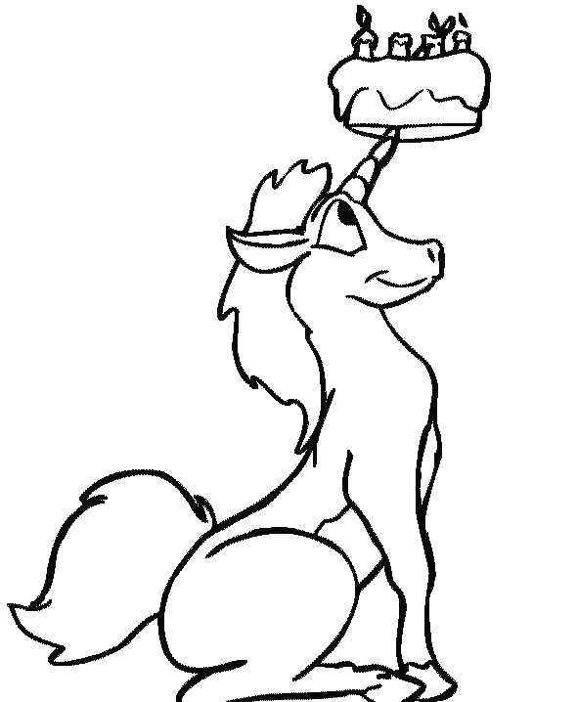

**Words to use**:

* unicorn
* cake
* stuck
* sitting

Wednesday- Writing

_____________________________________________________________________________________________________________________________________________________________________________________________________________________________________________________________________________________________________________________________________________________________________________________________________________________________________________________________________________________________________________________________

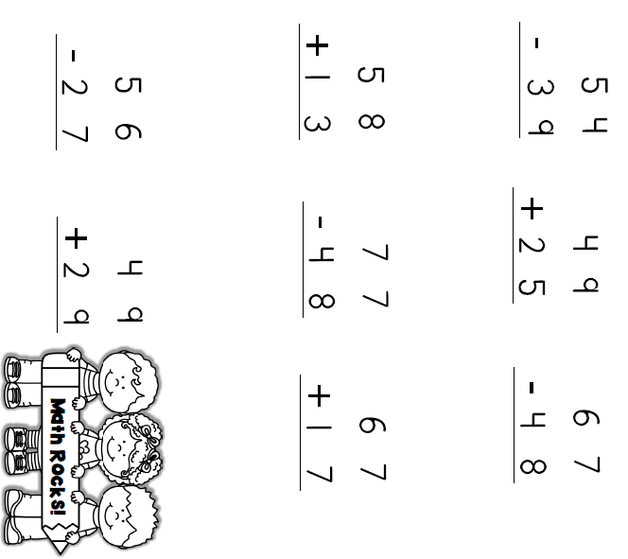

Wednesday- Math

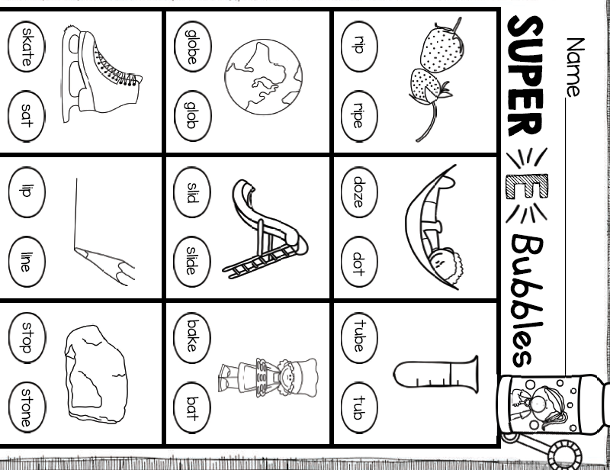

Wednesday- Skills





|  |  |
| --- | --- |
| **Thursday Activity Schedule** | |
| * **Check It Off When Completed** | **Activity** |
|  | Morning Work |
|  | Writing Journal page |
|  | Reading Comprehension Worksheet |
|  | Read a book and story map |
|  | 30 minutes of Lexia or RazKids |
|  | Math Worksheet |
|  | 30 minutes of SplashMath or Zearn |
|  | Skills Worksheet |
|  | *Choice activity time: pick an activity from the ClassDojo class story (watch a read aloud, try a learning website, or reading journal entry) or independent read for 20 minutes |

Morning Work- **Thursday**

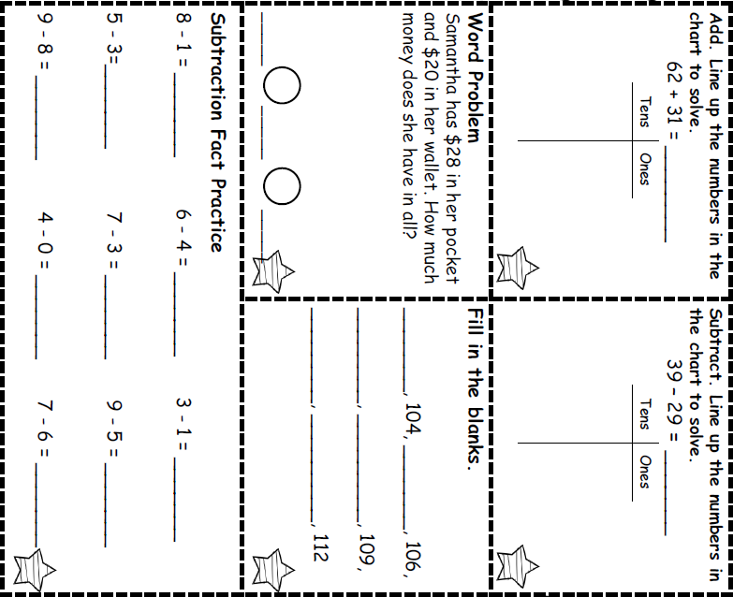

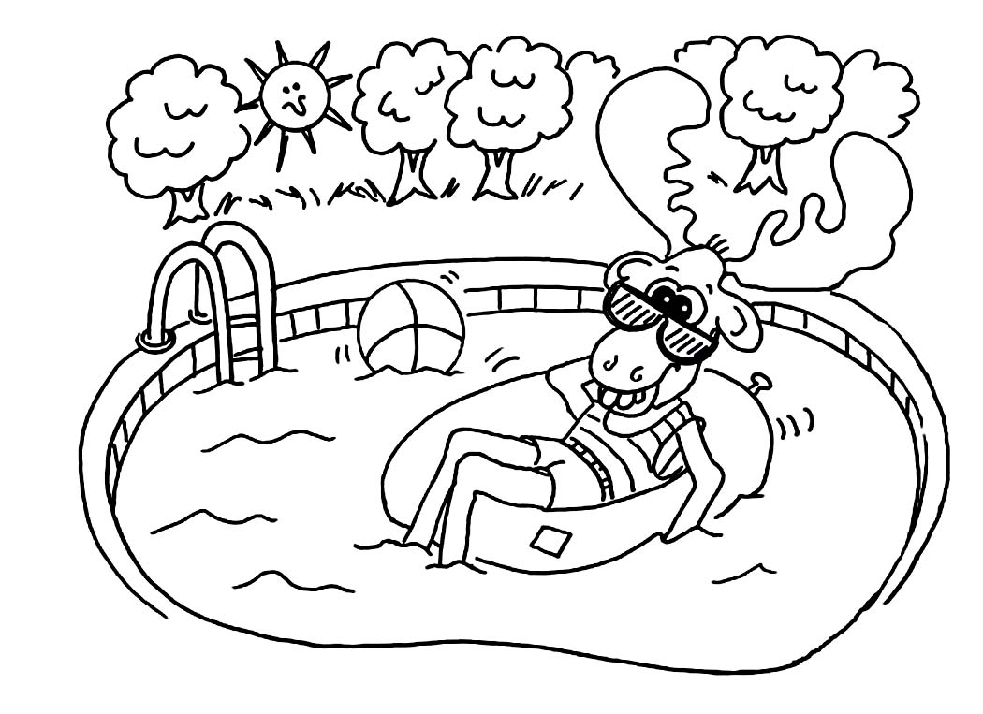

**Words to use**:

* moose
* pool
* beach ball
* relaxing

Thursday- Writing

_________________________________________________________________________________________________________________________________________________________________________________________________________________________________________________________________________________________________________________________________________________________________________________________________________________________________________________________________________________________

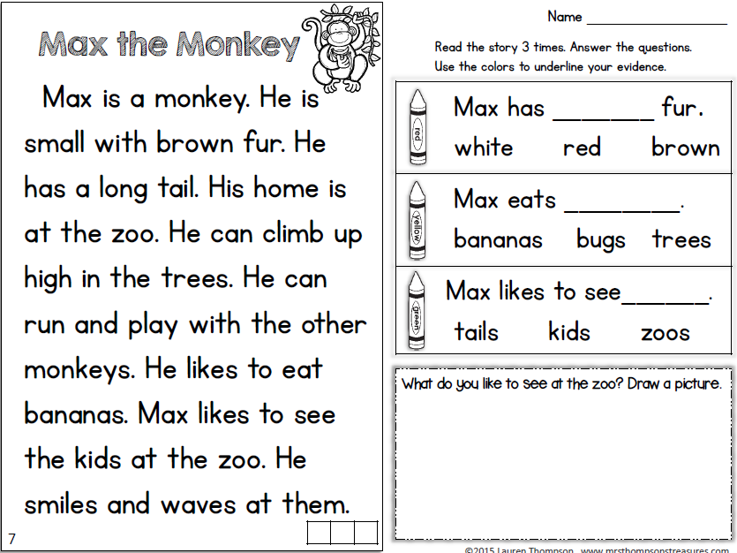

Thursday- Reading

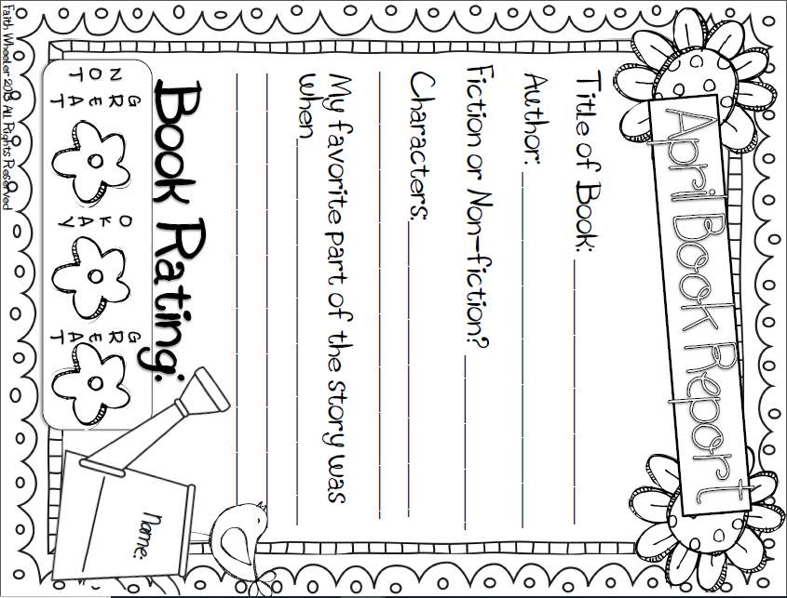

Thursday- Math

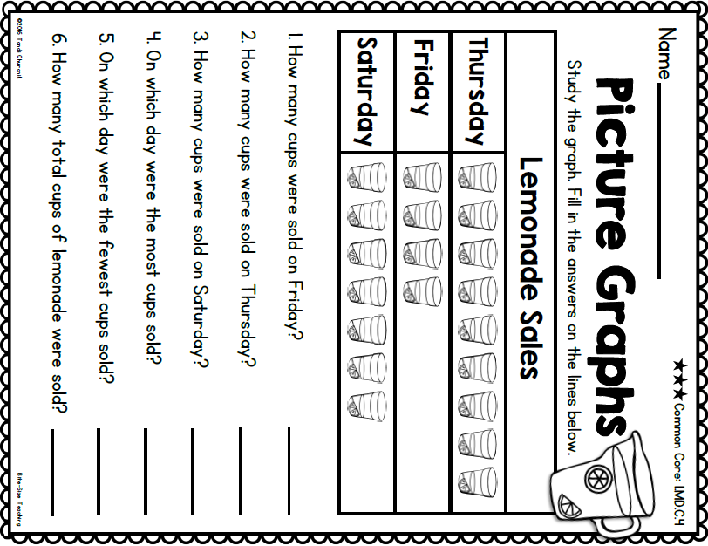

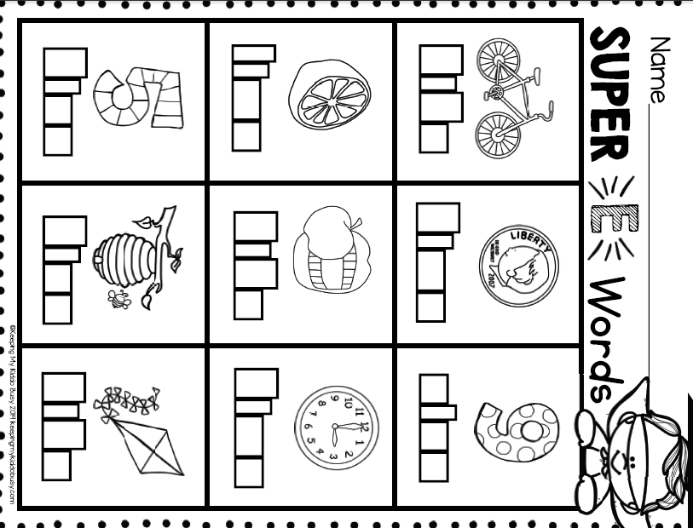

Thursday Skills



|  |  |
| --- | --- |
| **Friday Activity Schedule** | |
| * **Check It Off When Completed** | **Activity** |
|  | Morning Work |
|  | Writing Journal page |
|  | Reading Comprehension Worksheet |
|  | 40 minutes of Lexia or RazKids |
|  | Math Worksheet |
|  | 40 minutes of SplashMath or Zearn |
|  | Skills Worksheet |
|  | *Choice activity time: pick an activity from the ClassDojo class story (watch a read aloud, try a learning website, or reading journal entry) or independent read for 20 minutes |



Morning Work- **Friday**

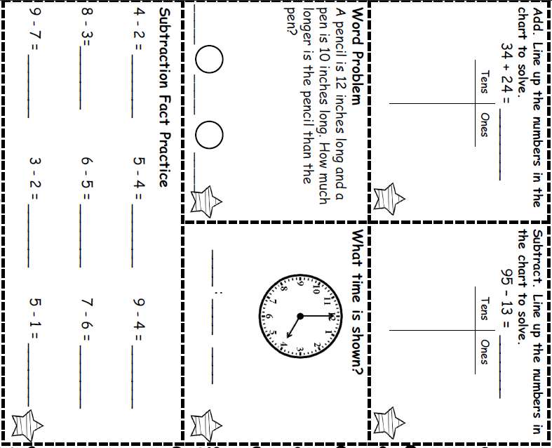

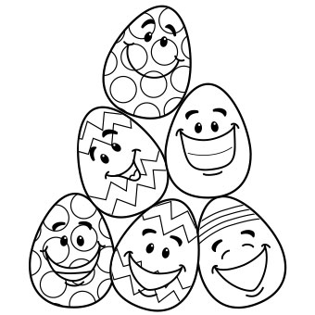

**Words to use**:

* eggs
* stacked
* pyramid
* friends

Friday Writing

_________________________________________________________________________________________________________________________________________________________________________________________________________________________________________________________________________________________________________________________________________________________________________________________________________________________________________________________________________________________

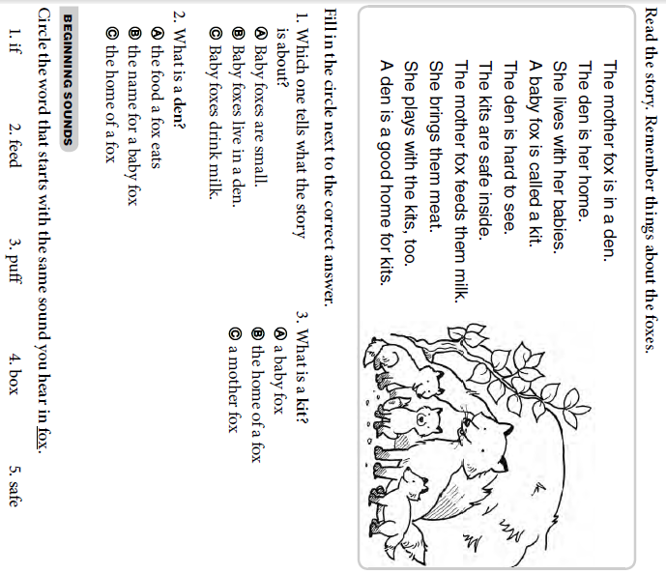

Friday Reading

Friday Math

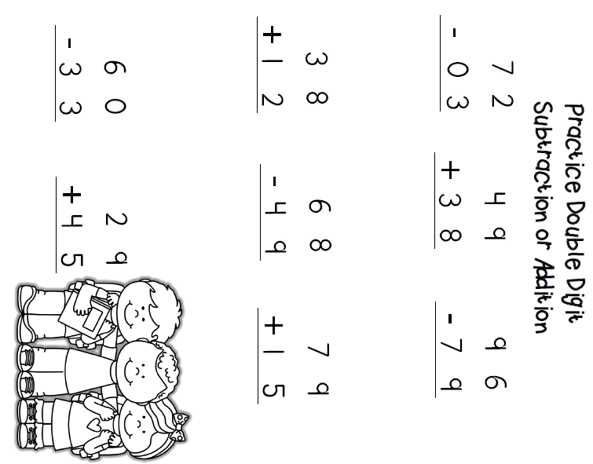

Friday Skills

